**Celedrax Garos** 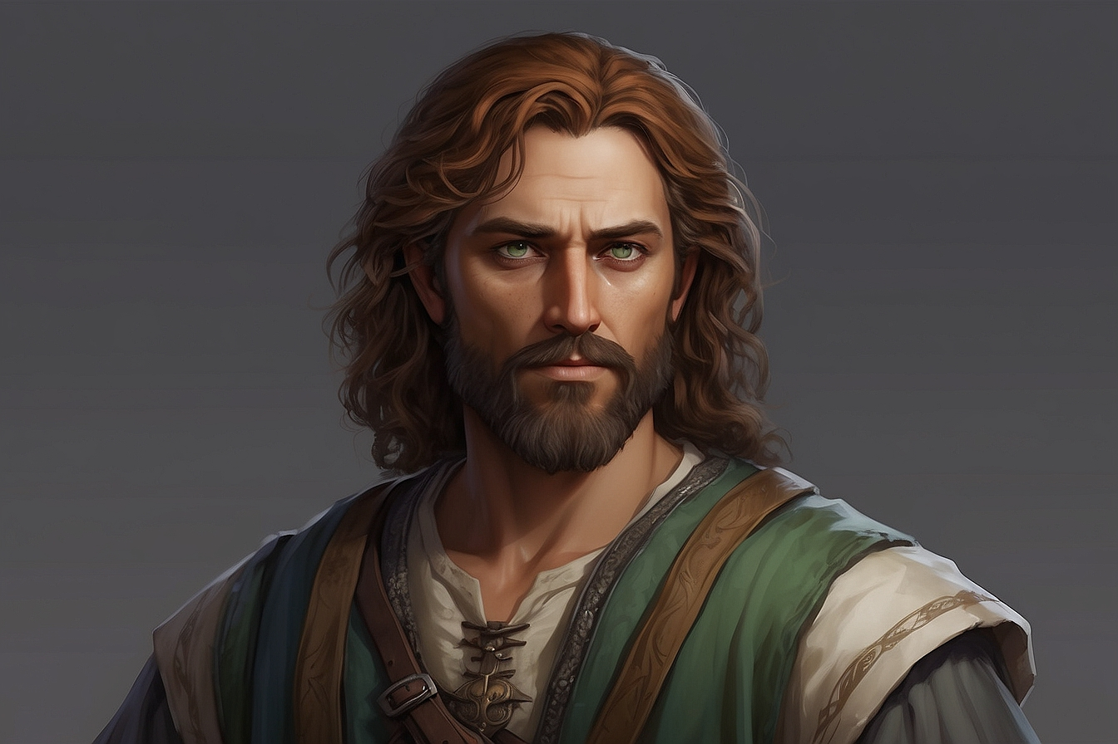

**Merchant**

**Ard Ipholar**

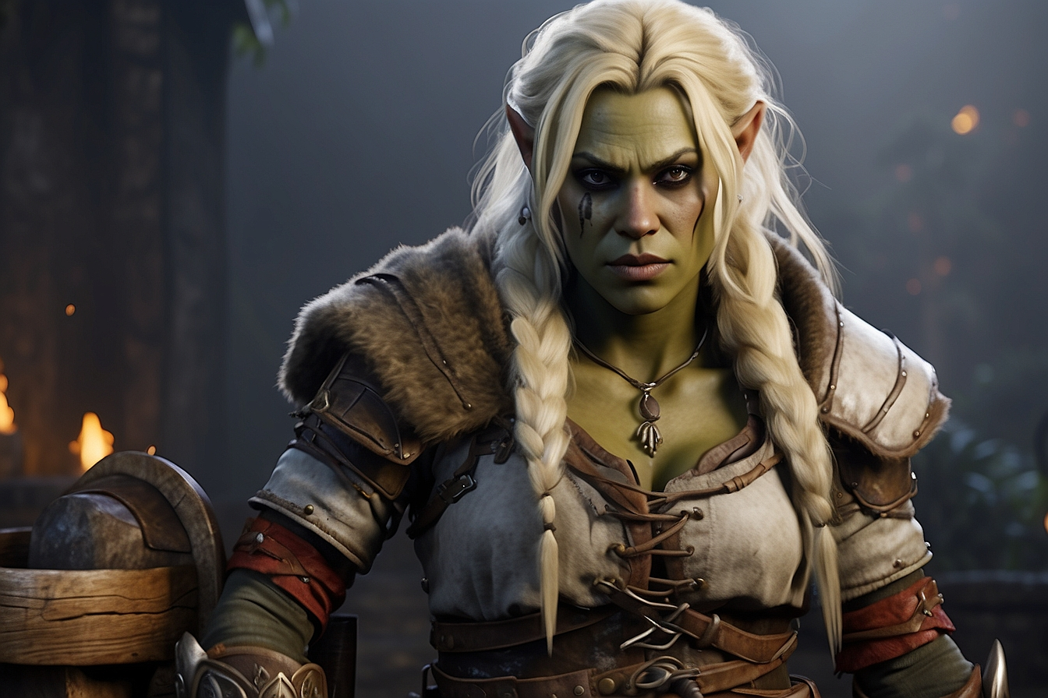

Half-orc launderer

**Bithritrilb Thoure** 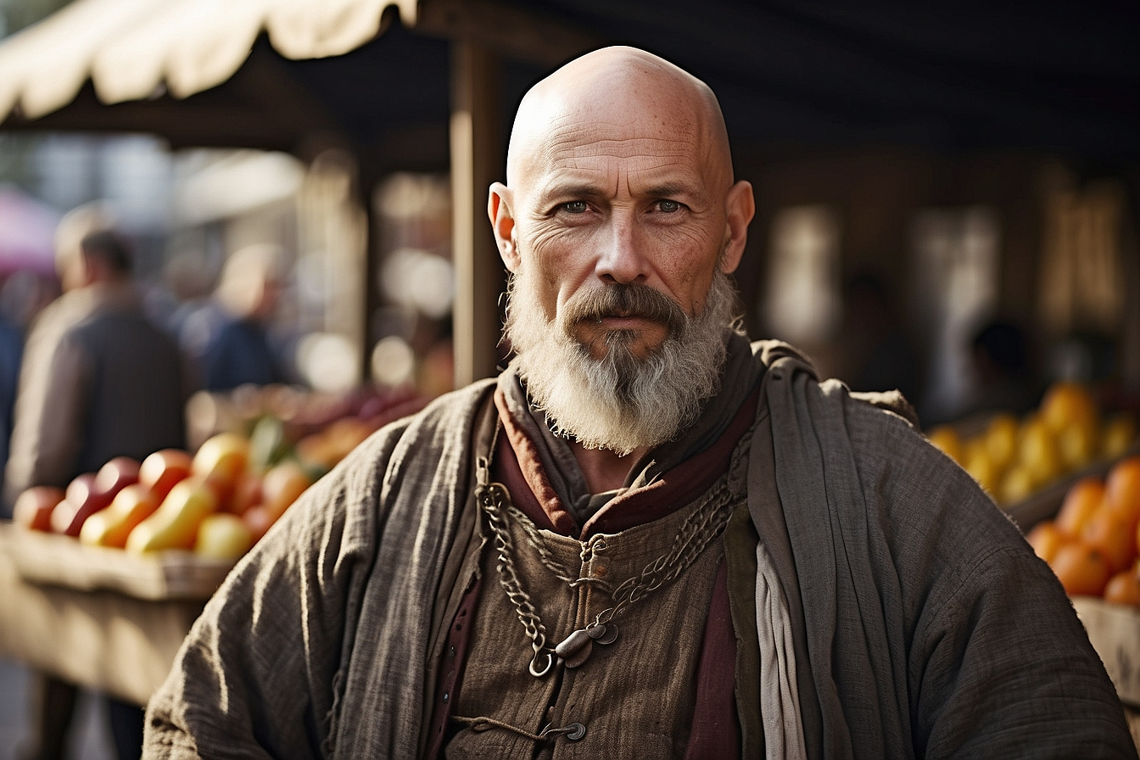

Merchant

**Barahir Kavar**

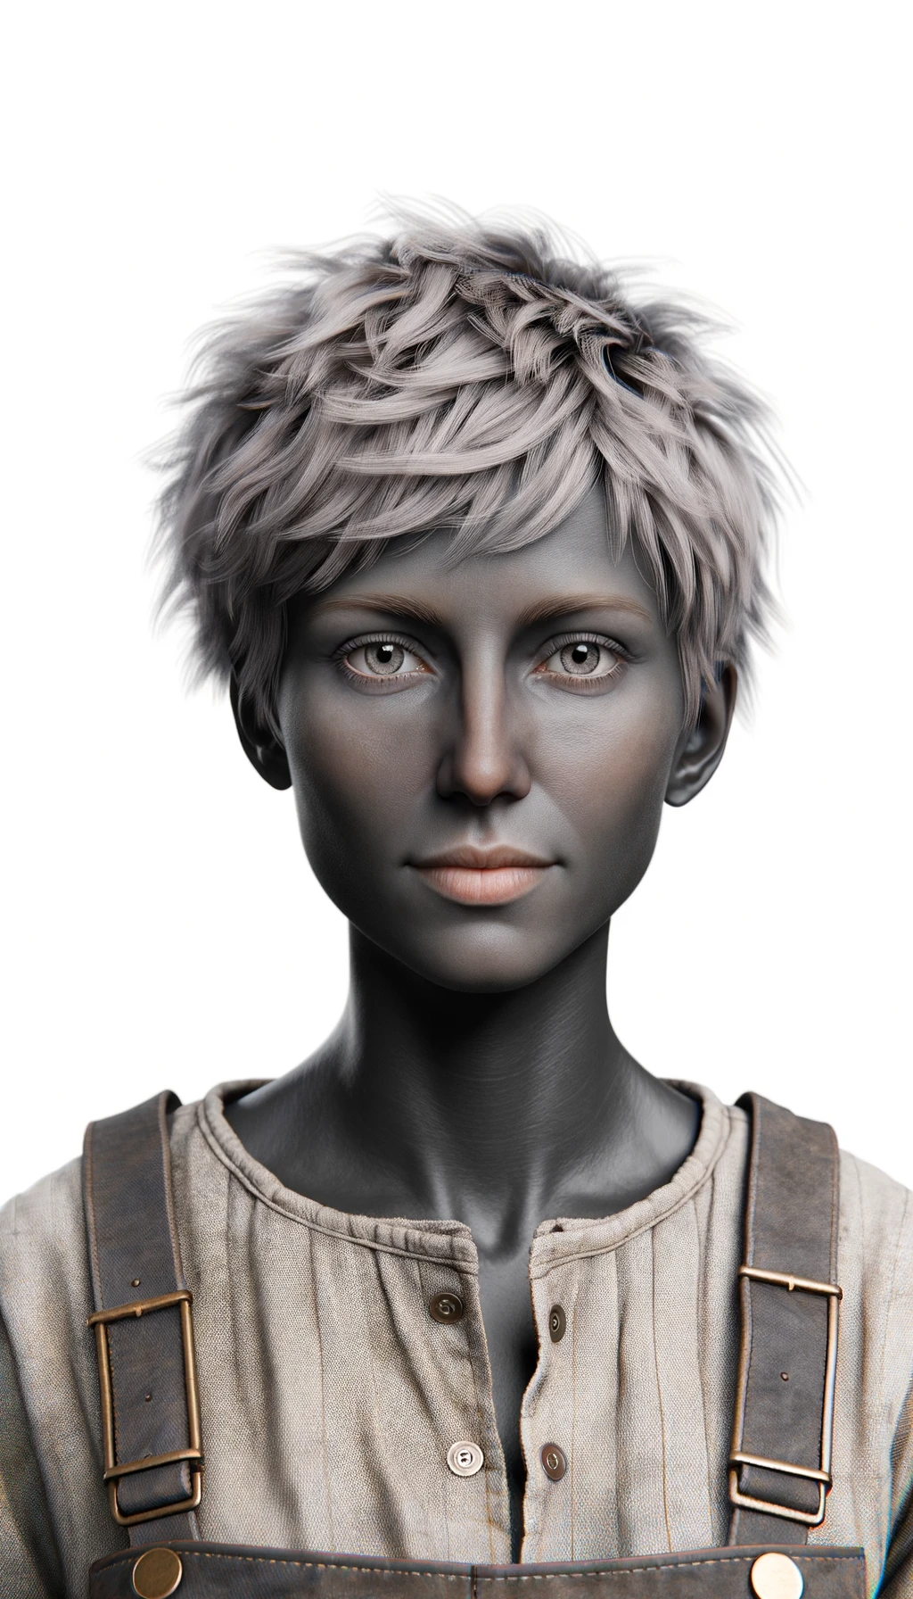

Labourer